Competencies for Translational Science Teams
Table 1 Domain Definitions
Domain | Definition
Facilitating Team Affect | Emotional bonds between team members that are grounded in expressions of genuine care and concern for the welfare of others including empathy, affiliation, and rapport on the basis of shared regard for the others.
Team Communication | Communication is essential to collective activities, factoring in participants’ goals, ability to integrate knowledge, and expertise in interpersonal, relational, organizational, and pedagogical contexts.
Managing Team Research | Managing research and development organizations is, to a great degree the art of integrating the efforts of its many participants.
Collaborative Problem Solving | Collaborative problem solving (CPS) is an essential skill in the home, the workforce, and the community because many of the problems faced in the modern world require teams to integrate group achievements with team members’ idiosyncratic knowledge.
Team Leadership | The cognitive, motivational, affective, and coordination processes associated with influencing organizational team performance.

Table 2 Competencies Mapped to Domains
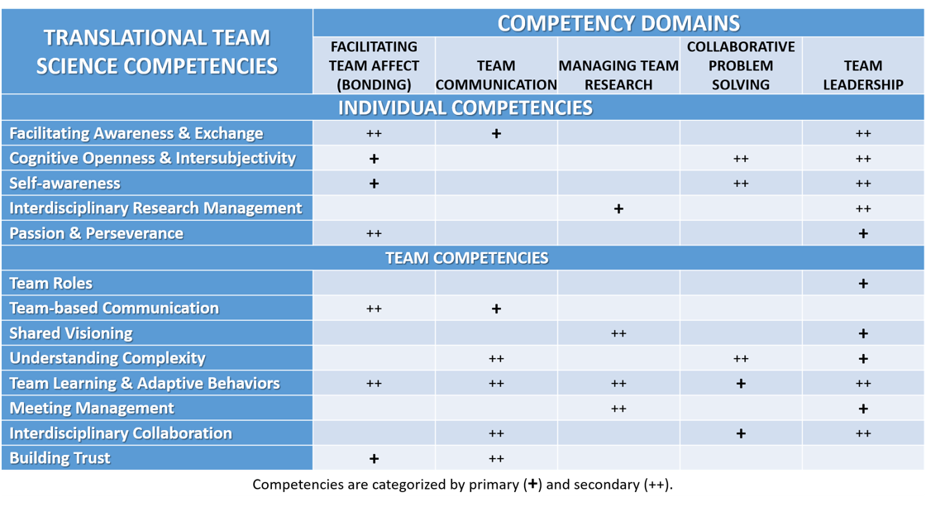

Table 3 Individual Competencies to Improve Translational Team Performance
Competency | Definition
Facilitating awareness and exchange | Sharing information and perspectives from a team members expertise. This includes inquiring and gaining insights from other disciplines, active probing for creating a common mental model, and reframing based on input from other team members.
Cognitive Openness and Intersubjectivity | Recognizing that individuals have different perspectives based on their world view. An ability to relate and incorporate other world views of team members. Creation of an interactive environment. A sense of belonging to a team. Esprit de corps. Critical awareness about one's own discipline and how that relates to differing disciplinary knowledge on related problems. Ability to innovate collaboratively.
Self-Awareness | Knowledge and understanding of personal styles, tendencies, strengths, and weaknesses. Understanding when one's preferred approach may need to change to better meet the needs of a team member.
Interdisciplinary Research Management | Ability to manage diverse and multi-team systems. Develop team skills to strengthen team structure and dynamics.
Passion and Perseverance | Long term commitment and perseverance. Ability to overcome barriers and be resilient when facing failures.

Table 4 Team Competencies to Improve Translational Team Performance
Competency | Definition
Team Roles | Identifying team members. Establishing role clarity through delineating responsibility and aligning responsibility with authority. Building and applying team agreements.
Team-based Communication | Paying attention to verbal and nonverbal cues, learning how to speak to the issue at hand, ensuring others understand what you are discussing and ensuring that you understand others. Committing to understanding and listening to other team members. Creating fear-free communication and information exchange. Focus is on delivery and active listening. Definition includes shared authorship,
Shared Visioning | Individual acceptance of vision and adherence to movement towards the shared vision.
Understanding Complexity | Leadership structure that supports complex problem solving.
Team  Learning and Adaptive Behaviors | Collaborative construction and reconstruction. Having an openness to rearranging collaborative and knowledge arrangements. Engaging with those affected by the problem attempting to be solved. Adapting to the use of new approaches and tools to further team process and objectives. Planning for team transitions. Ability to improve, learn and grow. Adaptive learning and intentional facilitation of team learning/involvement during meetings and problem-solving sessions.
Meeting Management | Preparing, executing, and improving meetings effectiveness. Capacity to adapt flexibly and effectively to situational and intra-team challenges.
Inter-disciplinary Collaboration | Openness to using different methods of collaborative problem solving. Valuing Interdisciplinary or Transdisciplinary collaboration by engaging cross disciplines. Requires a cooperative spirit and mutual respect. Ability to measure individual needs against team goals. Demonstrate broad intellectual curiosity.
Building Trust | Ability to delegate/assume responsibility where team members are comfortable that work will be accomplished. Respect for others.
Intellectual Input Gaetano R. Lotrecchiano, Ed.D., Ph.D., Deborah DiazGranados, Ph.D., Jennifer Sprecher, B.S.I.E, M.S., Wayne T. McCormack, Ph.D., Dayan Ranwala, Ph.D., Kevin Wooten, Ph.D, Daniel Lackland, Dr.P., Heather Billings, Ph.D. and Allan R. Brasier, M.D., Claudia Lechuga, M.S., Cheryl London, D.V.M., Ph.D., Shannon Zenk, Alfred Vitale, Ph.D.. Full literature references available upon request.

