Preparing to Implement a New COVID-19 Vaccine

What is the Clinical Problem? In 2019, a novel SARS-CoV-2 virus started a global pandemic

What has the impact been?

World
27.6 million infected
898,000 deaths
US
6.35 million infected
190,000 deaths

Significant racial/ethnic/economic disparities
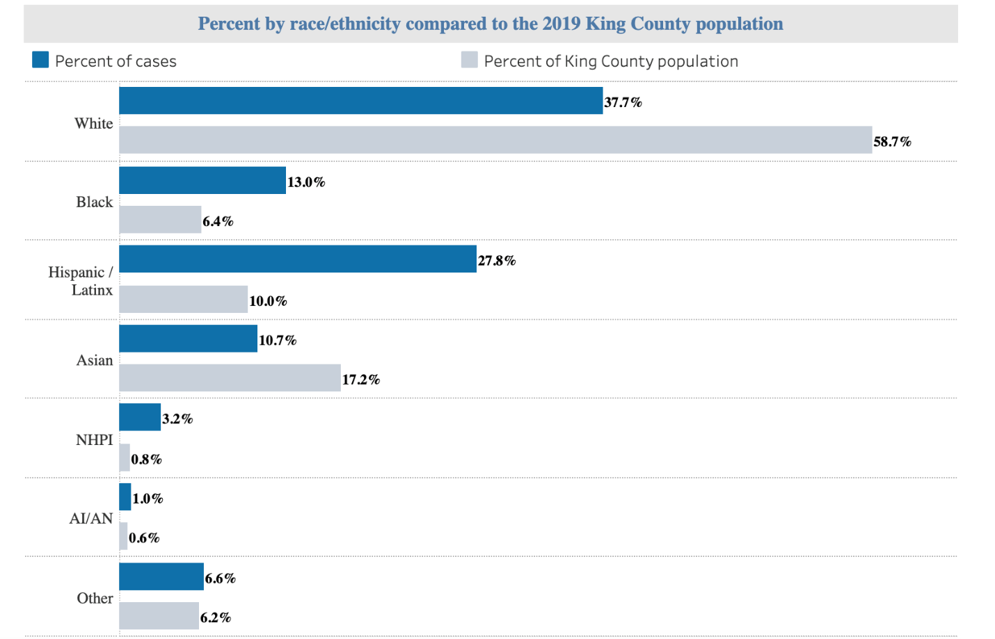

What are the limitations of current mitigation and management strategies?
Management strategies largely focus on 1) changing behavior to reduce virus transmission (masking, handwashing, social distancing) through education and public policy, and 2) testing and contact tracing
  - Economic and social disruption from social distancing measures
  - Only moderately effective
  - Political barriers to widespread and consistent implementation in the U.S.
  - Limited access to community wide testing and contact tracing

What is a possible solution? A new vaccine*
*This is a theoretical case study, not an actual vaccine

How does the vaccine work?
Messenger RNA (mRNA) supplies information that DNA uses to make proteins, which regulate cells and tissues
- mRNA in SARS-CoV-2 enables a “spoke protein” that pierces cells throughout the body
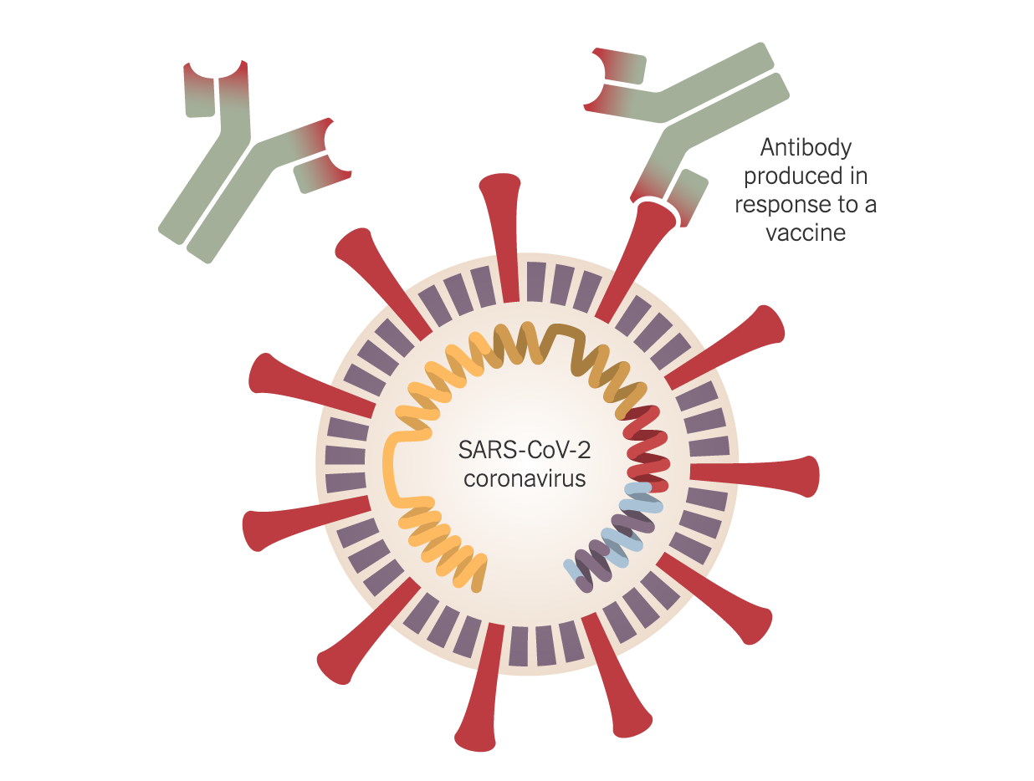
- mRNA vaccine contains synthetic mRNA that stimulates immune system into producing antibodies to viral proteins

Limitations of traditional viral vaccines (e.g. influenza or measles)
- In rare cases it can cause disease: Vaccine activates immune system by injecting small amount of attenuated virus or inactivated virus.
- Takes a long time to develop: grow weakened form of virus in chicken eggs, test which parts of virus successfully elicit antibodies – takes 4-6 months for annual flu vaccine. For a totally new virus like SARS-CoV-2, this process could take years or decades

Advantages of mRNA vaccine
- Does not contain any live or inactivated virus
- Faster to develop: researchers determine mRNA that results in SARS-CoV-2 producing proteins, create synthetic mRNA that is basis of new vaccine
- In early animal studies in the 1990s, mRNA vaccine delivery was dangerous – created an innate immune response (widespread inflammation), however, in mid-2000s, addition of carbon atoms to mRNA reduced inflammatory risk while preserving antigenicity function

Is the mRNA vaccine for SARS-CoV-2 safe and effective?
- In Clinical Trials, there is evidence that 50% of people who receive the vaccination series are protected. The rate of protective immunity is lower in children <5 and older adults (greater than 65).
- 10% of vaccine recipients experience a minor adverse event (e.g. arm discomfort)
- 0.1% of vaccine recipients experience a major adverse event (e.g. Guillane Barre Syndrome)
- Vaccine was co-developed by investigators at UW/Fred Hutch and a biotech company, and is FDA approved. Currently 100million 2-dose vaccines available for distribution in the U.S. An additional 200million 2-dose vaccines will be available by January 2021.
- 2-dose vaccine for ages 6mos and up, 4 weeks between doses

IMPLEMENTATION CHALLENGES
- Nation-wide pandemic – many people in need of vaccine!
- Single companies have insufficient production and delivery capacity to meet potential demand
- Not everyone is willing to get the vaccine, resistance not necessarily related to cost
- Vaccine cost is covered by most commercial and government insurances. Cost for self-pay is $250 for 2-dose series
- Think about where it should be administered and by whom – healthcare providers, public health staff, others

