Team Effectiveness Conditions Framework: Overview and Worksheet
The Team Effectiveness Conditions Framework has been tested and validated on a wide range of teams and predicts up to 80% of the variance in team effectiveness. It also identifies not only the best predictors (the Six Conditions) of team effectiveness but also the sequential relationship from the Six Conditions (3 Enabling and 3 Essential conditions), to Task Processes, and Team Outcomes.
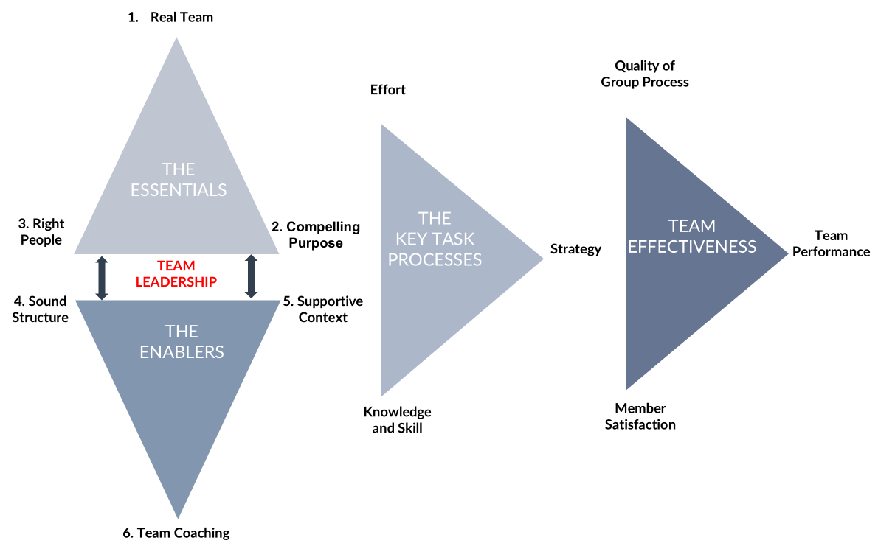
The Six Conditions are opportune places to intervene and improve and can be deliberately designed and implemented to create an environment that supports great teamwork and accomplishment.

What does it mean to be an effective team? Effective teams achieve all 3 of the criteria/outcomes below:
- Task Performance: Team’s task output meets or exceeds the needs of the team’s client(s).
- Quality of Group Process: The team becomes an increasingly capable performing unit over time.
- Membership Satisfaction: Member’s personal learning and growth are fostered by their experiences in the team.

What key task processes influence team effectiveness?
- Effort: How hard members work toward shared purposes.
- Strategy: The quality of the team’s approach to the work.
- Knowledge and Skill: How well the team uses its full range of capabilities.

What are the best places to focus efforts on improving task processes and overall team effectiveness? The Six Conditions

3 Essential Conditions
- Real Team (Bounded, Interdependent, Stable)—Members experience themselves as a team, with shared accountabilities and a need to work together to accomplish their goals?
- Compelling Purpose (Specifying Ends vs. Means)—The team’s reason for existence is clear, offers engaging challenges, and has meaningful impact on the lives and work of others.
- Right People—The team size is appropriate for the workload but not too large; the team has a range of perspectives and the configuration of skills—including teamwork skills—needed to accomplish the purpose.

3 Enabling Conditions
- Sound structure (Work Design)—The team performs motivating work that aligns with the team purpose and deploys ground rules and learning-based work practices to make the most of team talent.
- Supportive organizational context (Organizational Support)—The structures and systems in the larger enterprise promote teamwork rather than place obstacles in the way of meaningful collaboration.
- Team coaching—Someone with skill at intervening in teams is readily available to help the team consolidate learning and make increasingly good use of its resources in performing the work (could be a member of the team or an external person).

Assess and Improve Your Team’s Design: Diagnostic Checklist
This checklist was created to help you think through what features of your own team most need attention to improve their effectiveness. Start by grading each of the elements (i.e. 1a, 1b, 1c) from A (really superb, needs no work at all), to F (We fail completely, this condition is in poor shape for us); then give an overall grade for each of the Six Conditions.
 | Grade  (A, B, C, D, F) | Questions, notes, how might your team improve your design?
3 Essential Conditions
- Real Team
1a. Everyone knows exactly who is/not on the team; we are well bounded
1b. Membership stays the same for significant periods of time; the team is stable
1c. The team is interdependent for a common purpose; we need to work closely together to accomplish it
- Compelling Purpose
2a. Our team purposes are clear: everyone knows what success would look like
2b. The team’s purpose is genuinely consequential for the lives and work of others
2c. The team purpose is challenging but attainable
- The Right People
3a. The team has a good mix of perspectives and abilities, neither too alike nor too different
3b. All team members possess the necessary skills—including teamwork skills—to achieve its purpose
3 Enabling Conditions
- Sound Structure (Work Design)
4a. Our tasks make sense for a team to perform
4b. The team is a good size for its work
4c. The team has explicit norms of conduct that specify acceptable and unacceptable behavior
- Supportive Context (Organizational Support)
5a. The organization rewards team excellence
5b. We have access to the information/data we need
5c. Technical consultation/training is readily available
5d. We have all the material resources we need
- Expert Coaching
6a. Team coaching is available when we need it
6b. The coaching that is offered is helpful to our team’s development

Use this space to identify 2-3 areas for further exploration and/or improvement and to begin to plan next steps.

