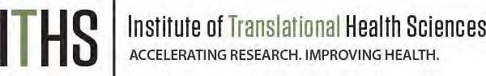

Resource Sharing Plans
When resources have been developed with NIH funds (such as the K12 Award) and the associated research findings published or provided to NIH, it is important that the results be made readily available for research purposes to qualified individuals within the scientific community.
Please read below to see if you need to prepare any documentation to accompany your K12 application. If any of the below criteria apply to your proposed project, please include all of the relevant plans in your application packet (2-page maximum for each required plan). If none of these criteria apply to your proposed research, you do not need to include anything further in your application packet.

Data Sharing Plan
- A Data Sharing Plan or an explanation of why data sharing is not feasible is expected to be included in all applications where the generation of data is anticipated and direct costs of $500,000 or more in any year of the proposed research is requested. (Examples of Data Sharing Plans can be found here)

Sharing Model Organisms
- If the development of model organisms is anticipated in the proposed project, please include a description of a specific plan for sharing and distributing unique model organism research resources generated using NIH funding or state why such sharing is restricted or not possible. This is NOT subject to a cost threshold of $500,000 or more in direct costs in any one year.

Genomic Data Sharing (GDS)
- Applications that involve the generation of large-scale human and/or non-human genomic data are expected to include a Genomic Data Sharing Plan, regardless of the requested costs. (Examples of Genomic Data Sharing Plans can be found here)

